Petrel is leading oil industry interpretation software which incorporate variety of geophysical, topographical, geological, hydrogeological, oil reservoir data sets. It is a wide world in which huge types of data sets are combined to yield single output.
Data can be displayed in 2D (two dimensions) and 3D (three dimensions) Views.
Map View
- Geographic location of all kinds of data sets are presented in MAP VIEW. Variety of data sets including satellite imagery, locations of seismic lines, well locations, cultural feature locations (roads, buildings etc) are all together displayed in one view. Below is the satellite data map view.

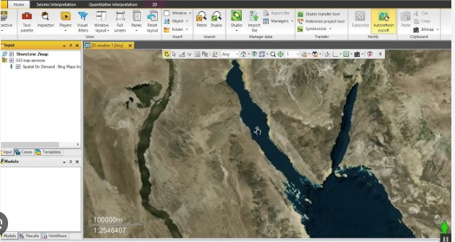

- Seismic lines with well locations
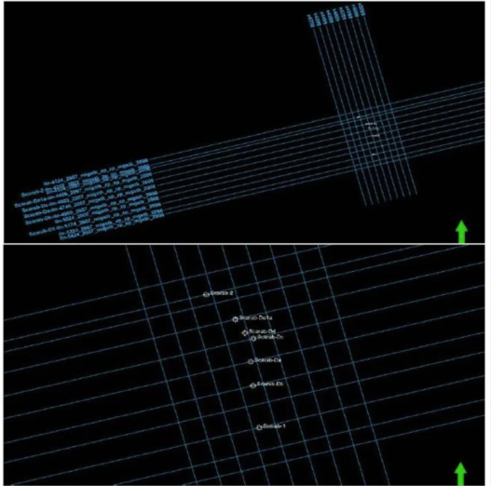
Sections View
Section view shows the 2D seismic data, well data, etc etc. Below shows a section view of seismic line.
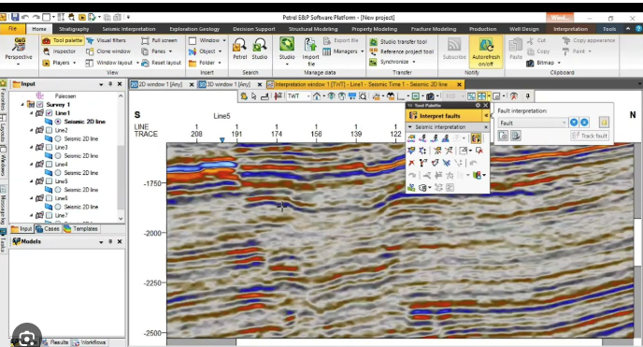

Both views are interactive, i.e. if you do one thing in seismic view, it will be automatically displayed in Map View and opposite is true also.

Similarly, all kinds of data is uploaded into petrel software and displayed automatically both in map and section views.

3D View
In addition, all data can be viewed, interpreted, displayed in 3D Views. They are also interactive with map and section views.

Below is a 3D view of seismic lines.

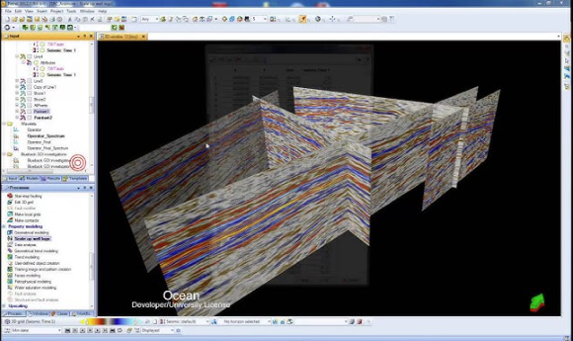

Below is the 3D view of reservoir data along with well.

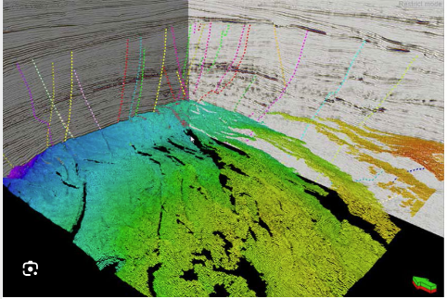

Petrel work in real world coordinates (lat/long) and projected coordinates (Easting, Northing).

